|  |  |
| --- | --- |
| **Fujifilm GF 32-64mm f/4 R LM WR Lens**  Ống kính Fujifilm GF 32-64mm f/4 R LM WR | Chính hãng  FUJIFILM GF 32-64mm f4 R LM WR  Chính hãng FUJIFILM GF 32-64mm f4 R LM WR  Chính hãng.1 FUJIFILM GF 32-64mm f4 R LM WR  Chính hãng.5 FUJIFILM GF 32-64mm f4 R LM WR  Chính hãng.4 | **Featured information:**   * Anti-vibration: No * Aperture: F4-32 * Closest focusing distance: 50mm * Filter size: 77mm   Price : 1700$  **Specifications:**   * **Focal distance:** 32 - 64mm * **Largest Aperture:** f/4 * **Smallest Aperture:** f/32 * **Lens Mount:** FUJIFILM G * **Lens Format:** Full-Frame * **View:** 46.3° - 81° * **Minimum Focus Distance:** 50 cm * **Magnification:** 0.12x * **Optical Components:** 14 Elements in 11 Groups * **Number of Mouth Blades:** 9 * **Focus Type:** Auto focus * **Anti-Vibration:** No * **Filter Size:** 77 mm (Front) * **Size:** 92.6 x 116 mm * **Weight:** 875 g |

**Description:**

**FUJIFILM GF 32-64mm f/4 wide-angle zoom Lens**

FUJIFILM GF 32-64mm f/4 R LM WR belongs to Fujifilm's G-mount medium format lens line , providing a 25-51mm equivalent focal length allowing photography of many genres, in many different situations. Constant f/4 maximum aperture provides consistent shooting performance throughout the entire zoom range, resulting in images that are always bright and noise-free in dark conditions.

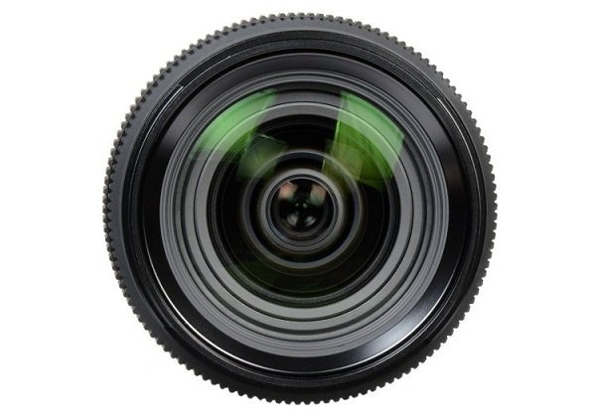

**The autofocus system is fast and smooth**

Integrating an internal focusing mechanism with a linear autofocus motor, the lens provides fast, smooth, and silent focusing performance, helping users capture every moment of life and preserve it. with quality frames and footage.



The 9-blade circular aperture diaphragm provides a rounded, eye-pleasing bokeh quality with the subject highlighted in the background and out-of-focus areas displayed smoothly and comfortably.